Agile Wildcats Test Cases

Team: Karri Fox, Ariel Austin, Justin Larimore, Robert Dillan and Richard Gingras

# Summary

83% Accuracy

19 PASS 4 FAIL

Tested on 11/23/2025

# Test Case 1: Required Degree Course Work (including semester courses are offered) – BS Program

## Steps:

1. Select **Required Degree Course Work (including semester courses are offered) – BS Program** from the drop-down menu
2. Press **Enter**
3. Evaluate response to match expected information.

## Expected Response:

Response should be found from the BS in Software Engineering PDF and contain information similar to this:

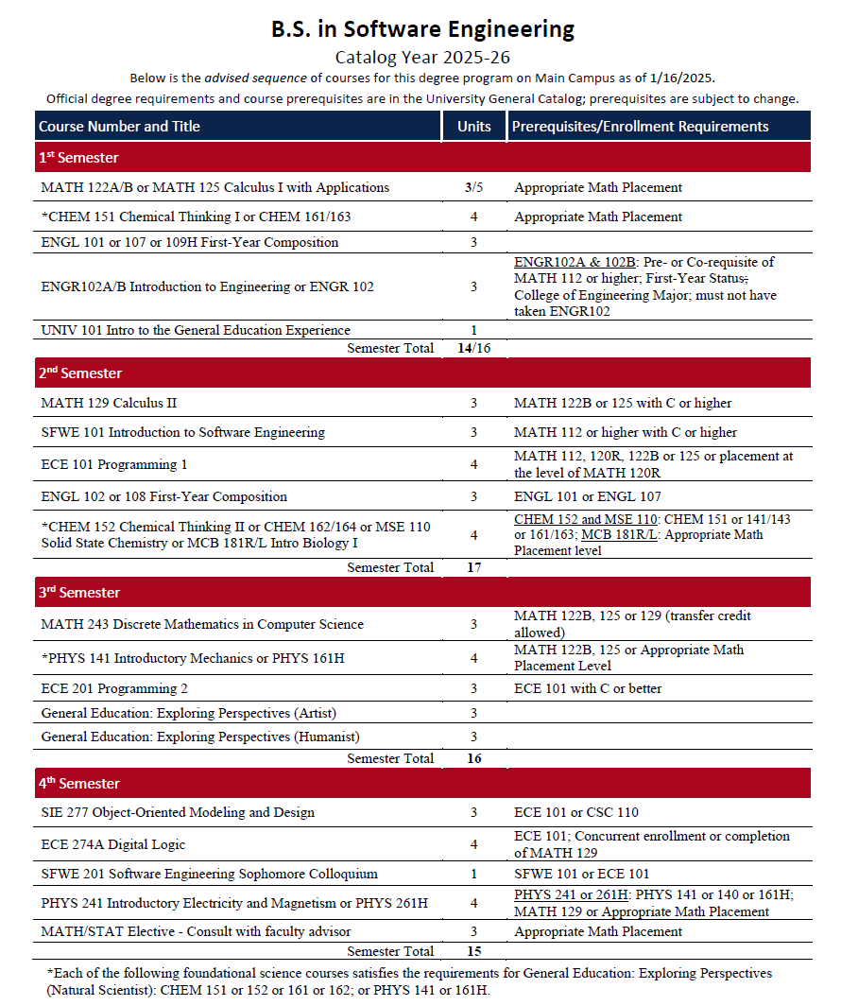 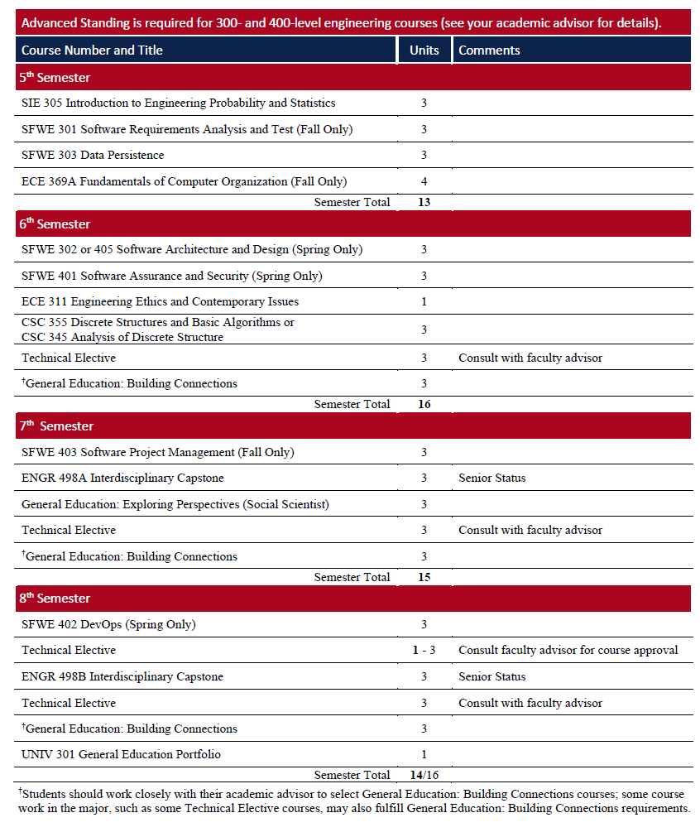

## Chatty Catty Response:

## Results: PASS

# Test Case 2: Required Degree Course Prerequisites – BS Program

## Steps:

1. Select **Required Degree Course Prerequisites – BS Program** from the drop-down menu
2. Press **Enter**
3. Evaluate response to match expected information.

## Expected Response:

Should be listing the prerequisite classes required for the classes within the program. This information can be found under the course name in the SFWE Arizona Online PDF.

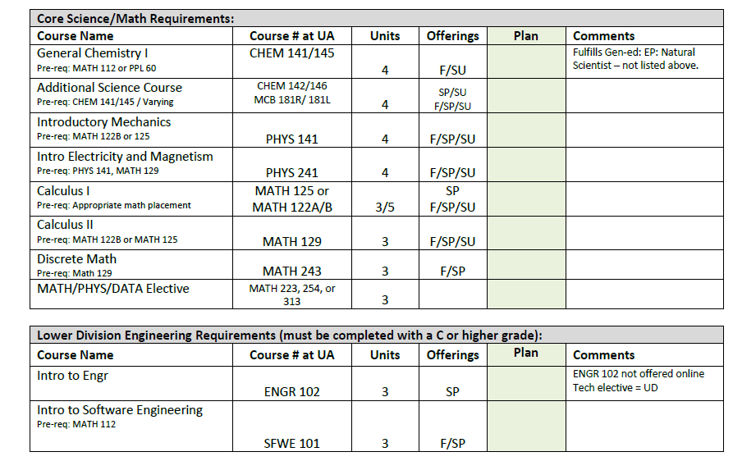

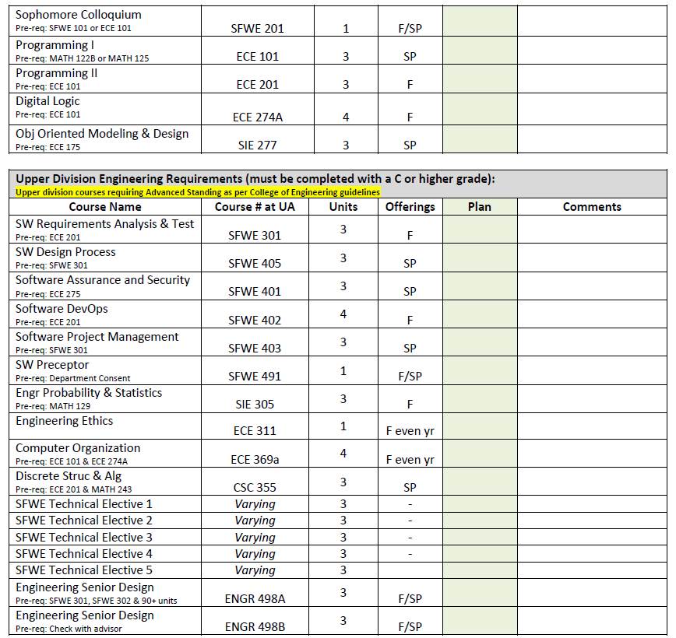

## Chatty Catty Response:

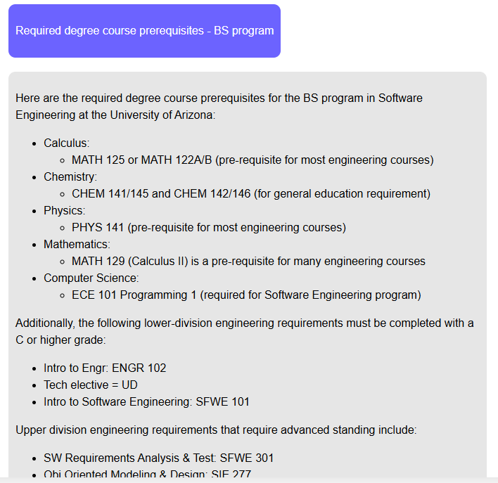

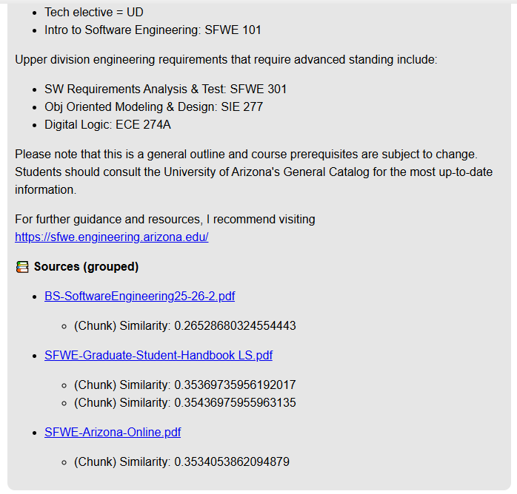

## Results: PASS

# Test Case 3: Undergraduate Admissions Requirements – BS Program

## Steps:

1. Select **Major Admissions Requirements – BS Program** from the drop-down menu
2. Press **Enter**
3. Evaluate response to match expected information.

## Expected Response:

The admission requirements for an undergraduate degree are expected to be similar to the ones found on the website: <https://engineering.arizona.edu/undergrad-admissions/freshmen> and <https://www.arizona.edu/admissions/resources/high-school-competency>

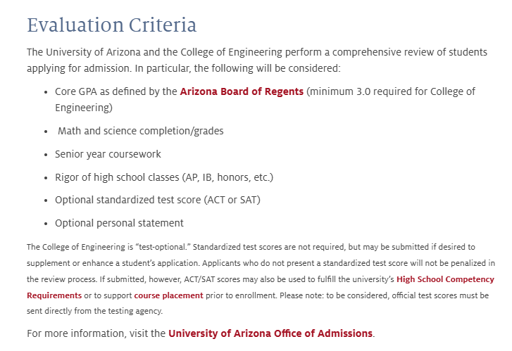

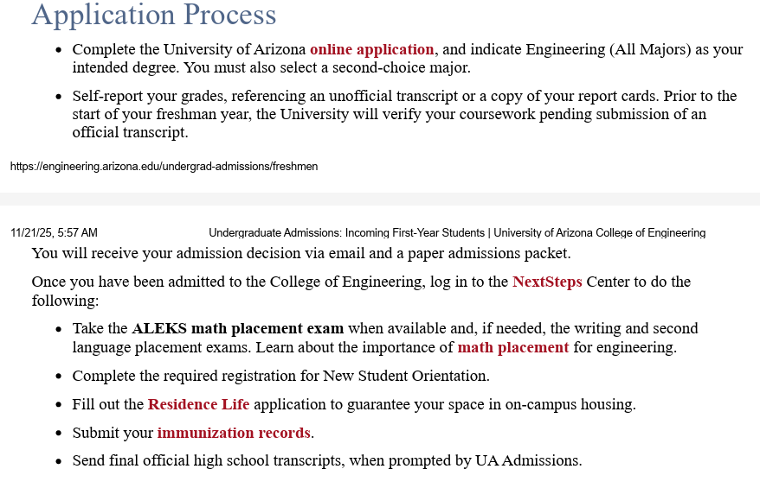

## Chatty Catty Response:

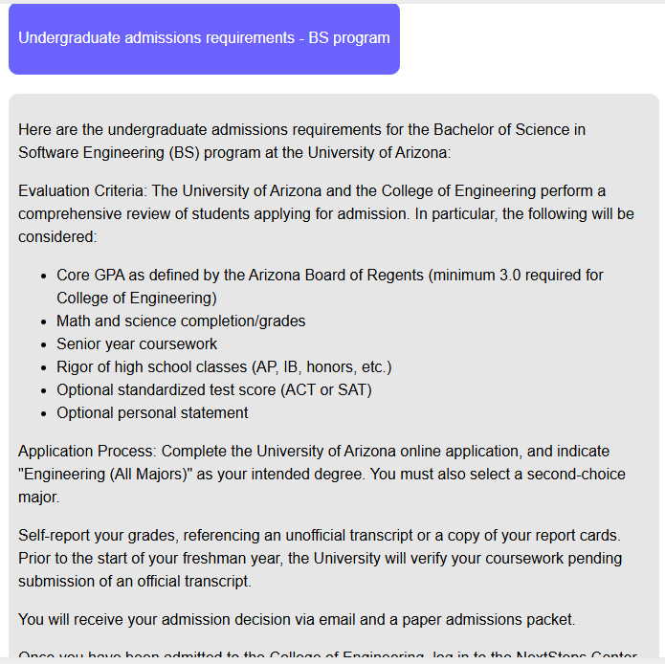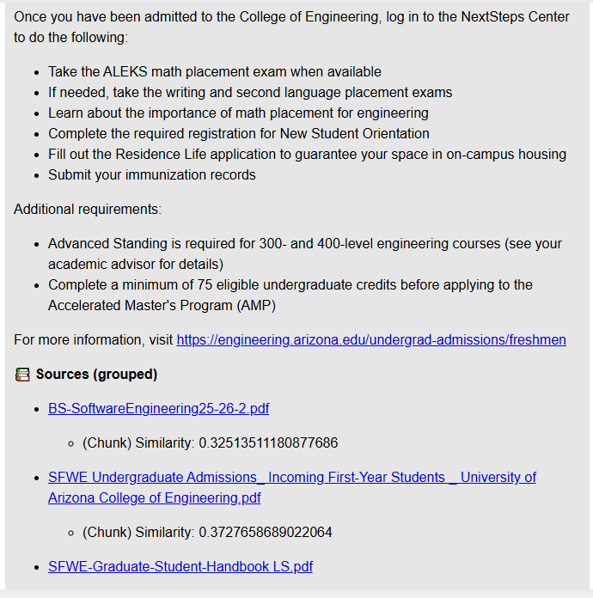

## Results: PASS

Results are not coming from pre-seeded file and it is therefore making them up.

# Test Case 4: Typical 4-year Course Planning Guide (On Campus or Distance Student)

## Steps:

1. Select **Typical 4-year Course Planning Guide (On Campus or Distance Student)** from the drop-down menu
2. Press **Enter**
3. Evaluate response to match expected information.

## Expected Response:





## Chatty Catty Response:

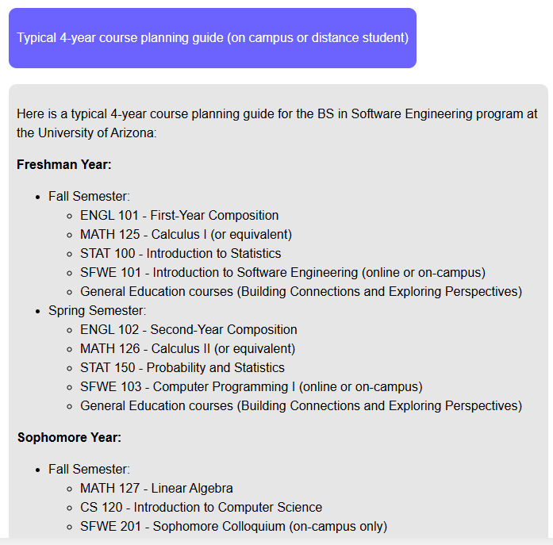

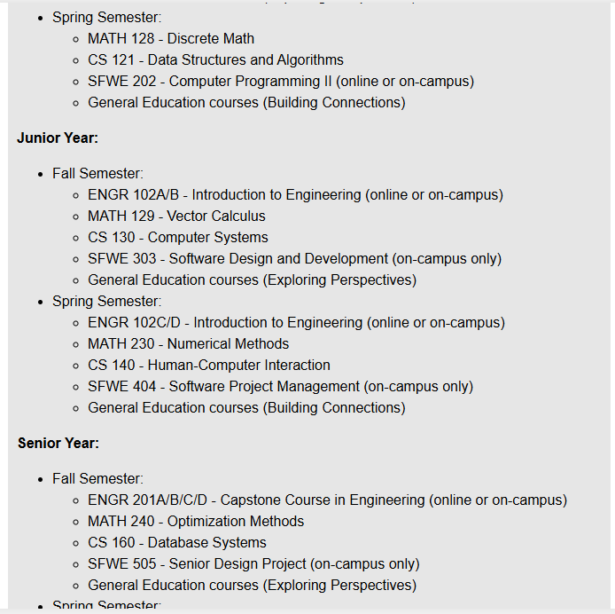

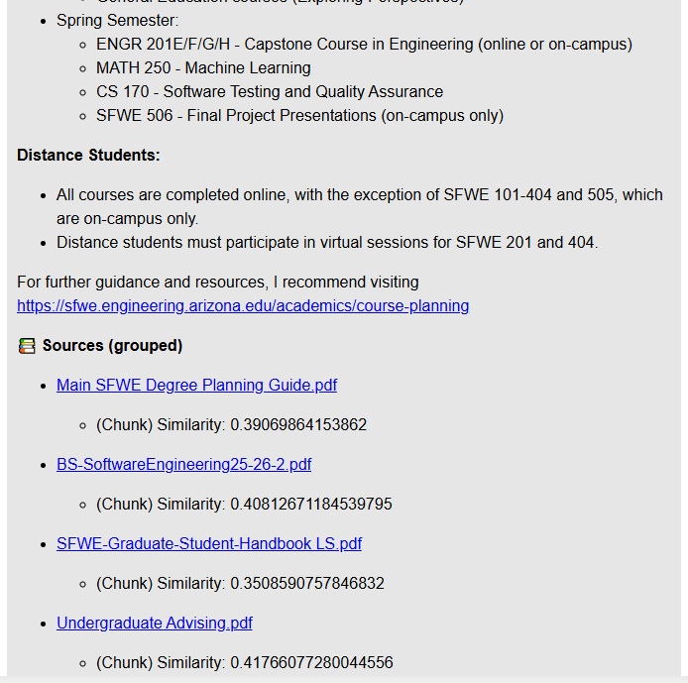

## Results: PASS

# Test Case 5: Typical 4-year Course Planning Guide (Online Campus)

## Steps:

1. Select **Typical 4-year Course Planning Guide (Online Campus)** from the drop-down menu
2. Press **Enter**
3. Evaluate response to match expected information.

## Expected Response:

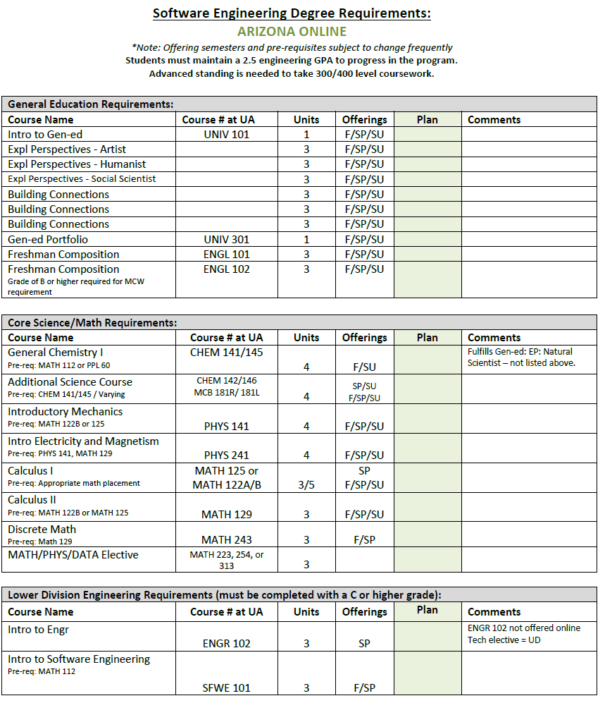

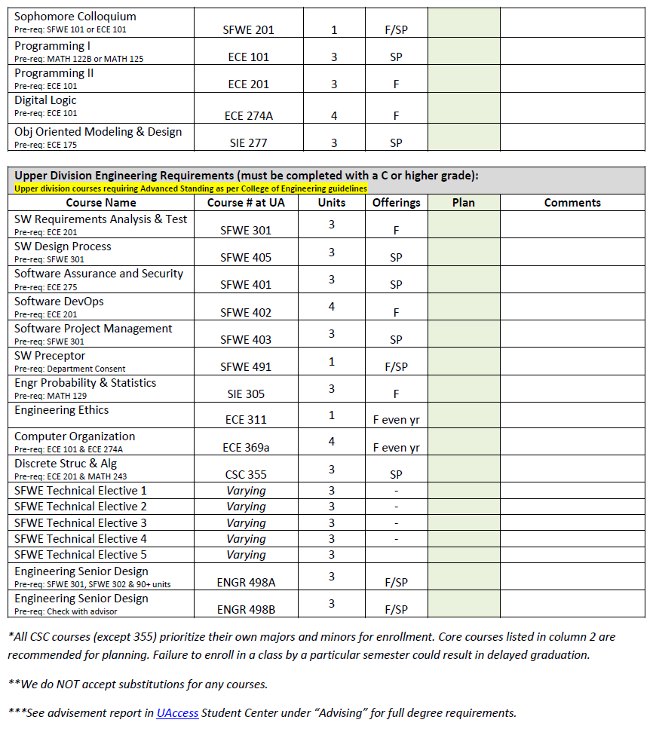





## Chatty Catty Response:

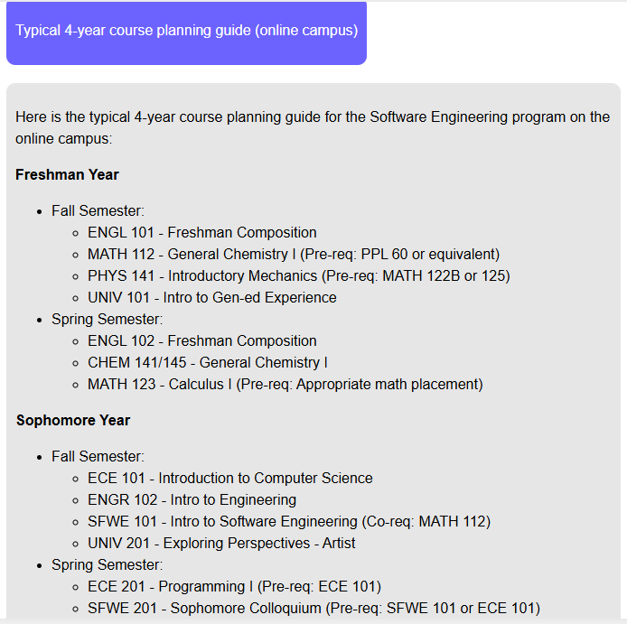

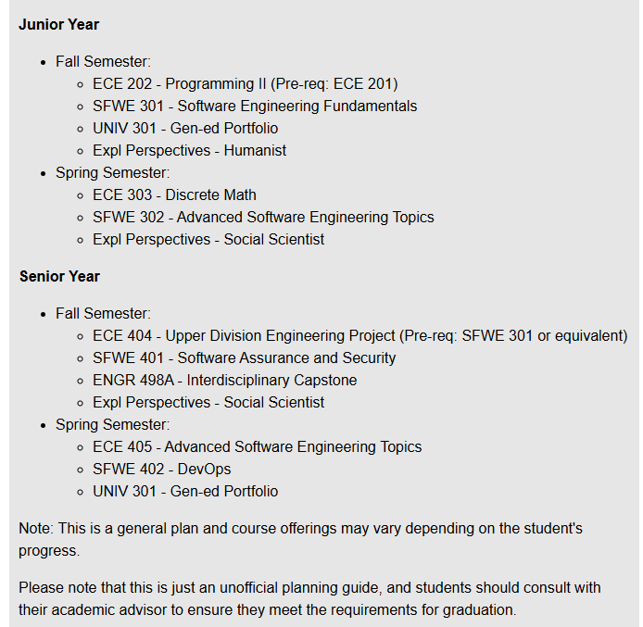

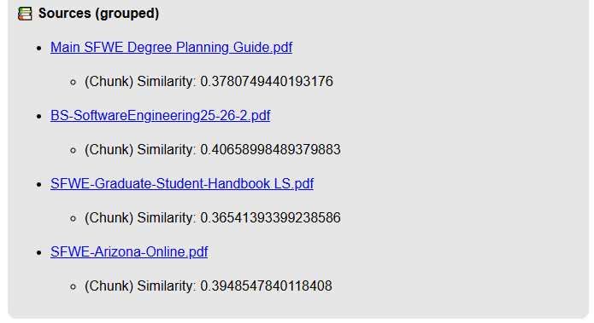

## Results: PASS

# Test Case 6: Pre-approved Undergraduate Technical Electives

## Steps:

1. Select **Pre-approved Undergraduate Technical Electives** from the drop-down menu
2. Press **Enter**
3. Evaluate response to match expected information.

## Expected Response:

## Chatty Catty Response:

Cannot find the list of approved electives. Some of the SFWE sites on Arizona.edu are not responding correctly.

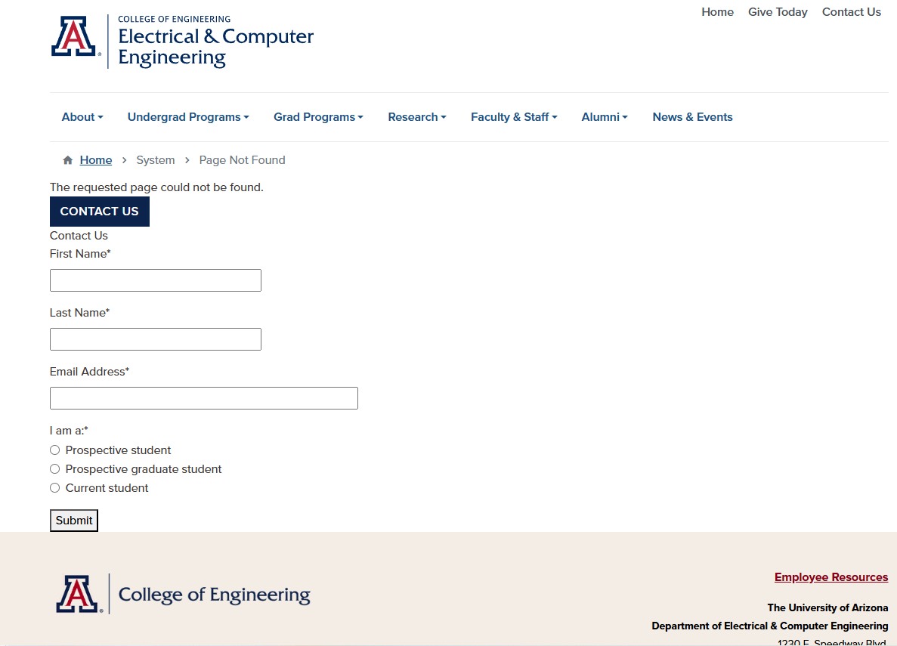

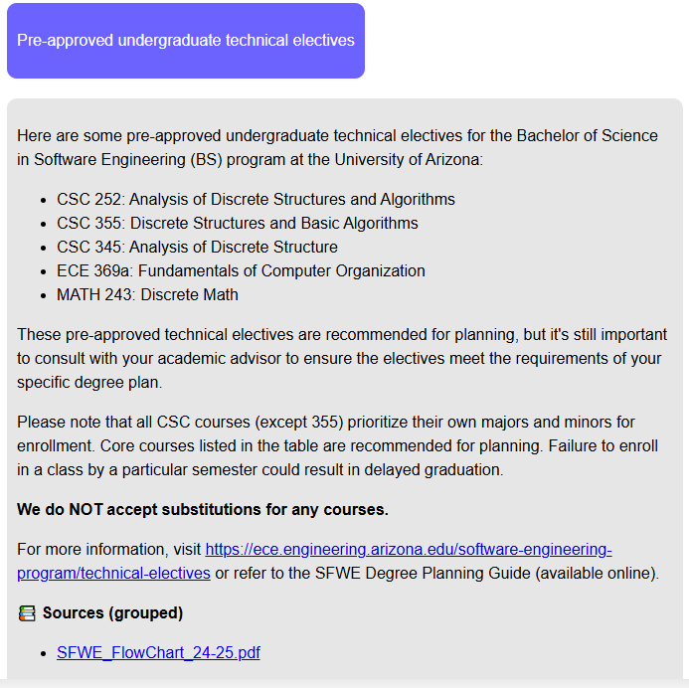

## Results: FAIL

Website it’s offering isn’t valid and per the flow chart the technical electives should only be 300 or 400 level courses and none of our existing documents specifically list the technical electives.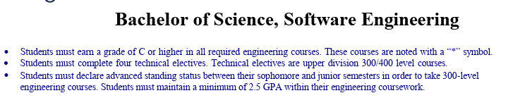

# Test Case 7: Transfer Credit Applicability

## Steps:

1. Select **Transfer Credit Applicability** from the drop-down menu
2. Press **Enter**
3. Evaluate response to match expected information.

## Expected Response:

Transfer credits are subject to the following restrictions:

* A maximum of 30 units of relevant coursework from another graduate degree may be transferred and applied toward the PhD requirements.
* The credits must first be reviewed and approved by the student’s faculty advisor.
* The minimum grade for transferred credits must be an A, B, or the equivalent at the institution where courses were taken.

## Chatty Catty Response:

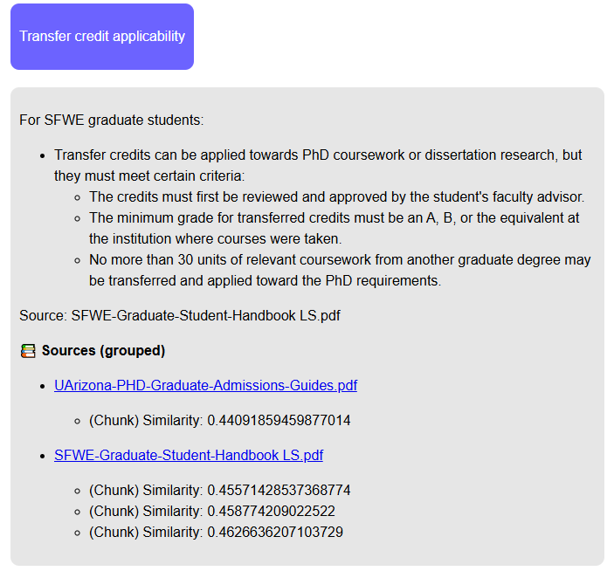

## Results: PASS

# Test Case 8: Course Registration Process

## Steps:

1. Select **Course Registration Process** from the drop-down menu
2. Press **Enter**
3. Evaluate response to match expected information.

## Expected Response:

Expected steps similar to the following:

1. Log into UAccess student portal
2. Check course availability
3. Add course to cart
4. Review cart and finalize registration

## Chatty Catty Response:

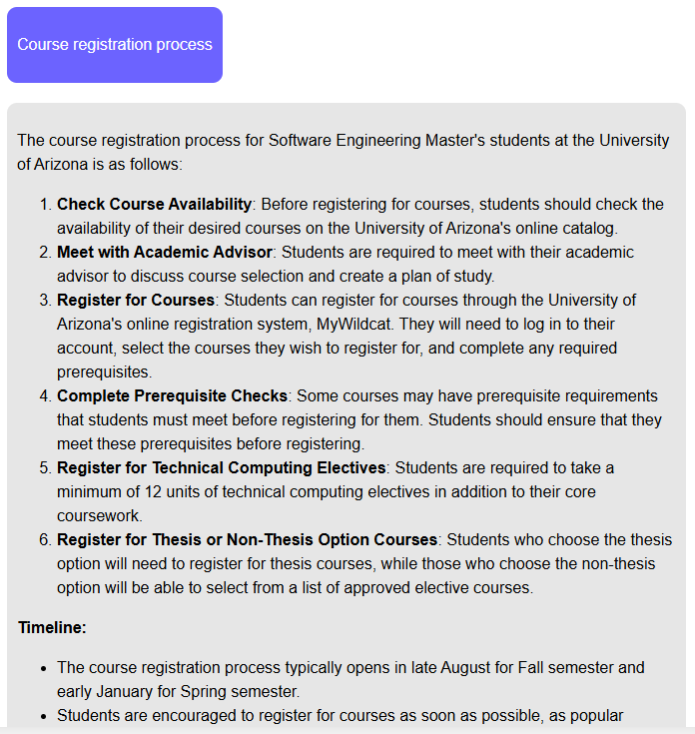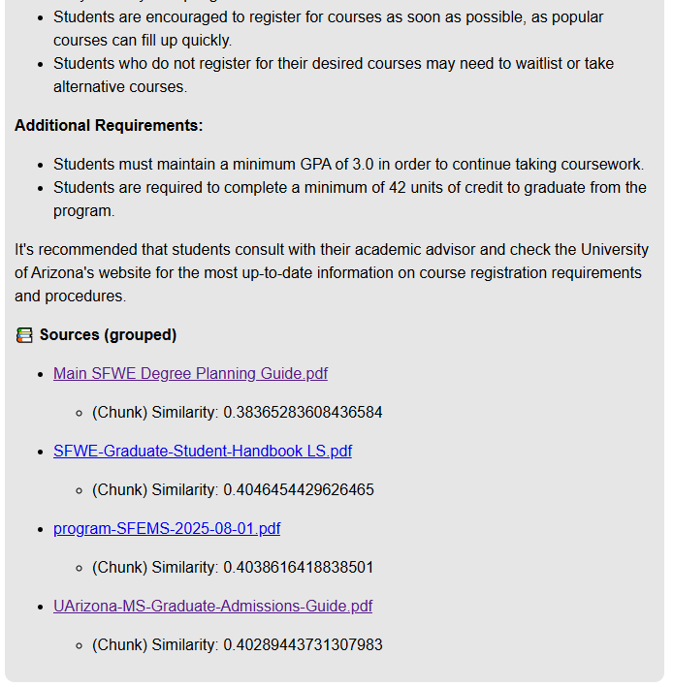

## Results: FAIL

42 units is not required for a master’s degree. These steps are not coming from our documents.

# Test Case 9: Admission Requirements – MS Program

## Steps:

1. Select **Admission Requirements – MS Program** from the drop-down menu
2. Press **Enter**
3. Evaluate response to match expected information.

## Expected Response:

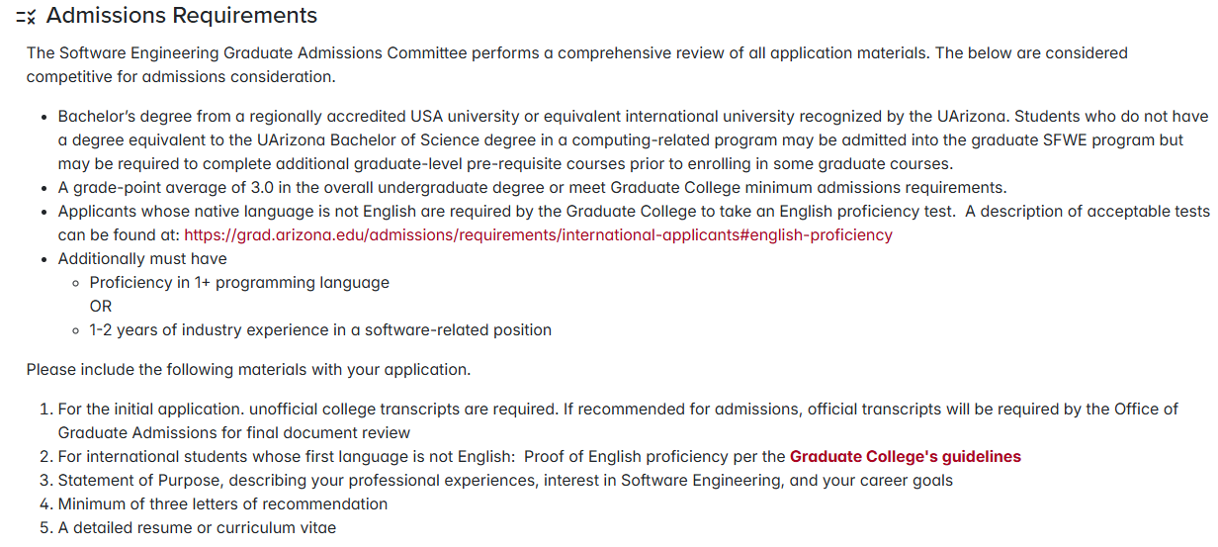

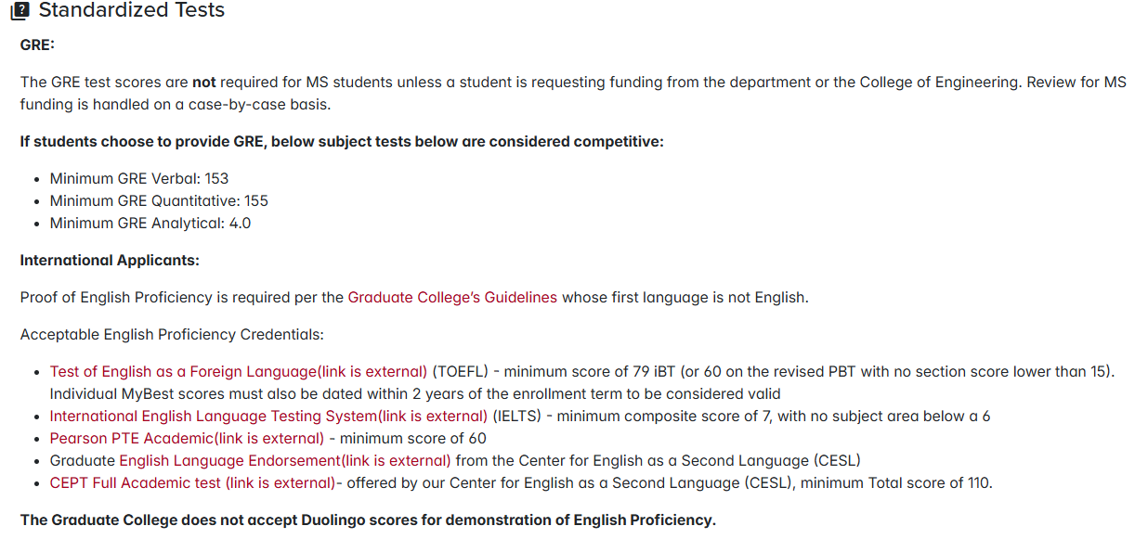

## Chatty Catty Response:

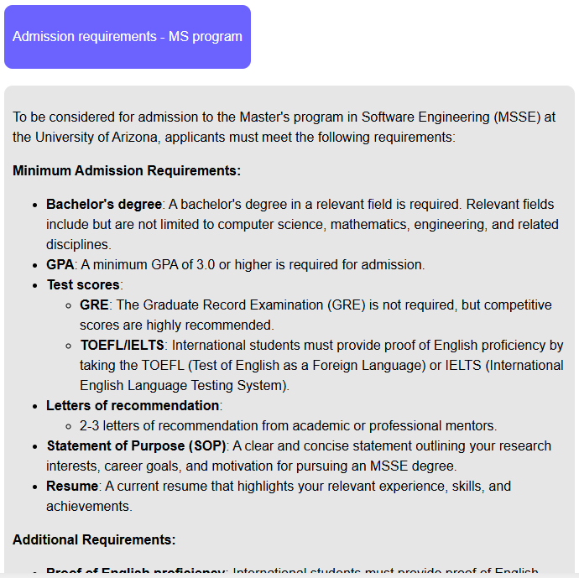

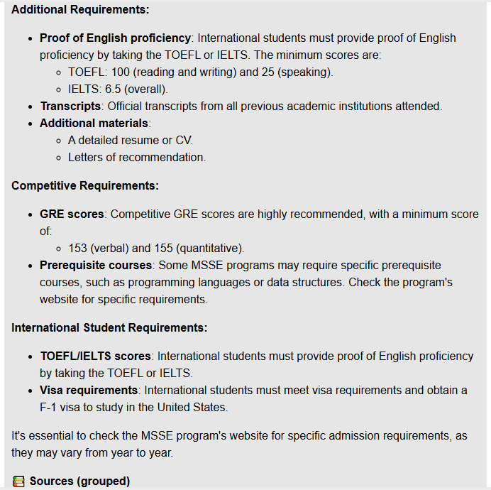

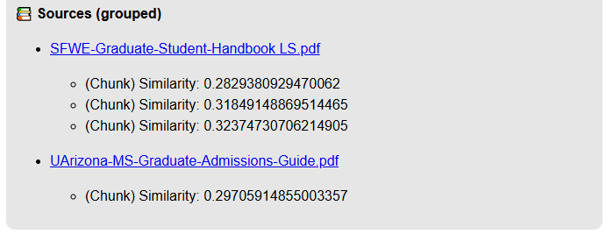

## Results: PASS

# Test Case 10: Required Course Work – MS Program

## Steps:

1. Select **Required Course Work – MS Program** from the drop-down menu
2. Press **Enter**
3. Evaluate response to match expected information.

## Expected Response:

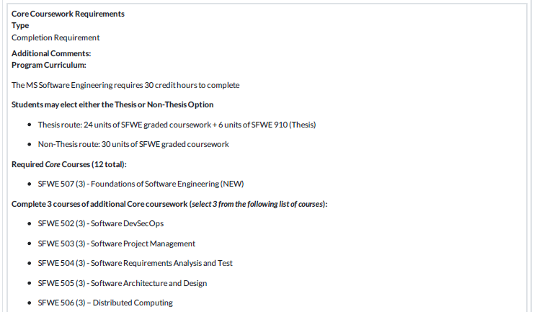

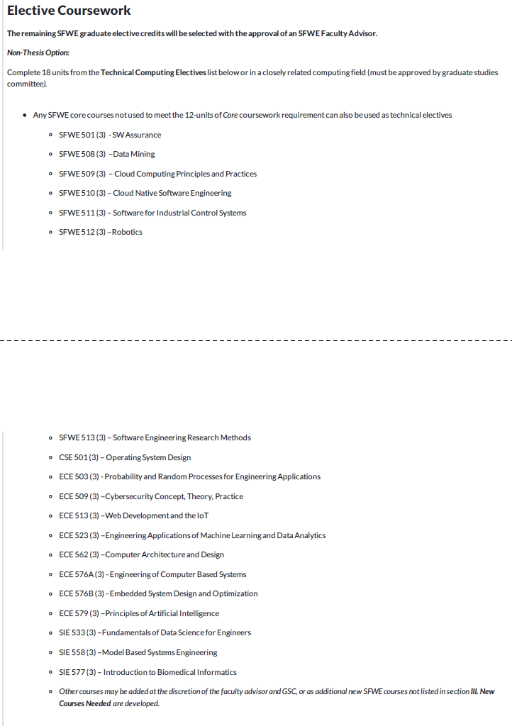

## Chatty Catty Response:

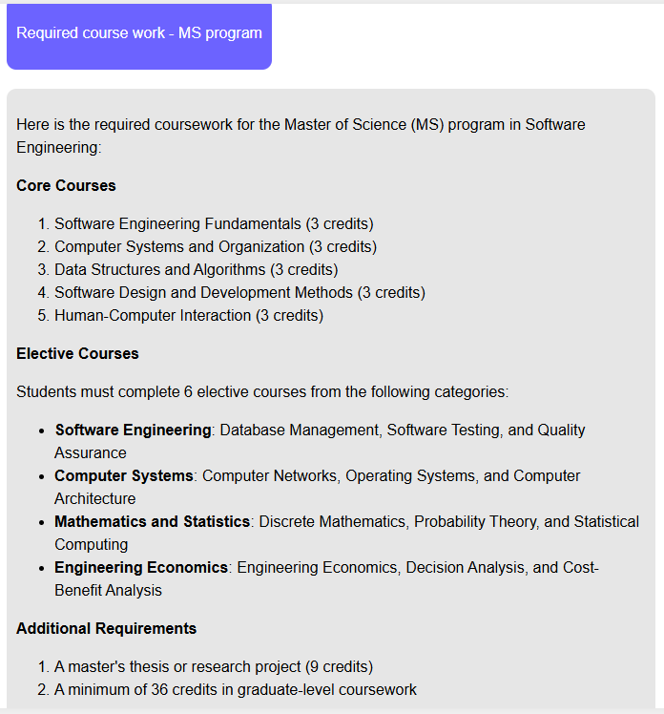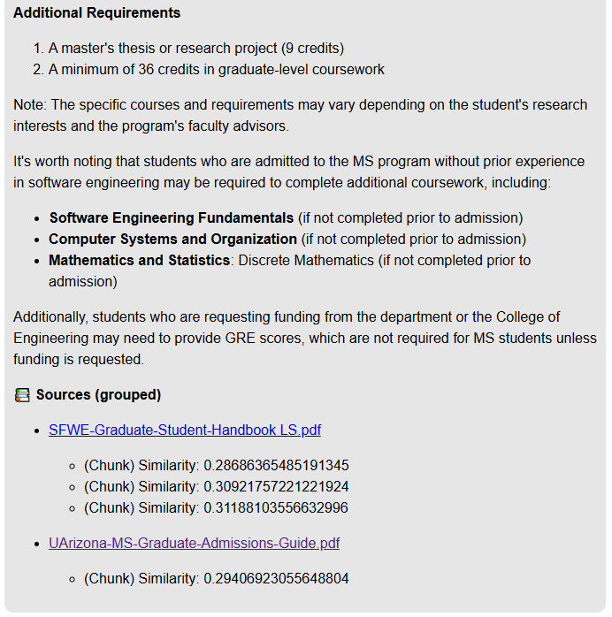

## Results: FAIL

Courses provide in query are not core courses for the MS in SFWE.

# Test Case 11: Required Course Prerequisites – MS Program

## Steps:

1. Select **Required Course Prerequisites – MS Program** from the drop-down menu
2. Press **Enter**
3. Evaluate response to match expected information.

## Expected Response:

Expect to see prerequisites for the following classes:

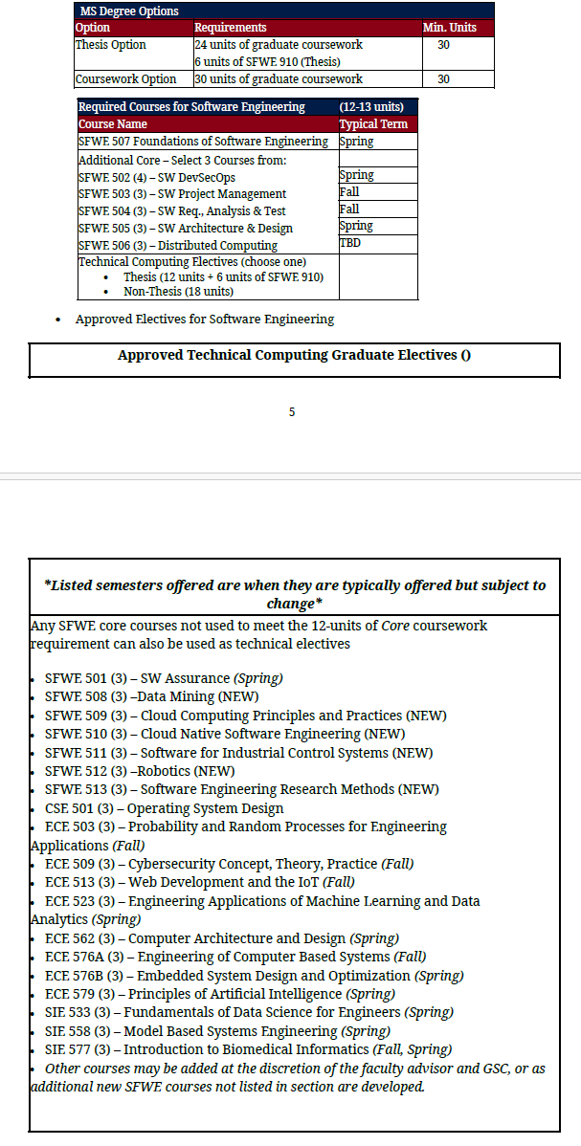

## Chatty Catty Response:

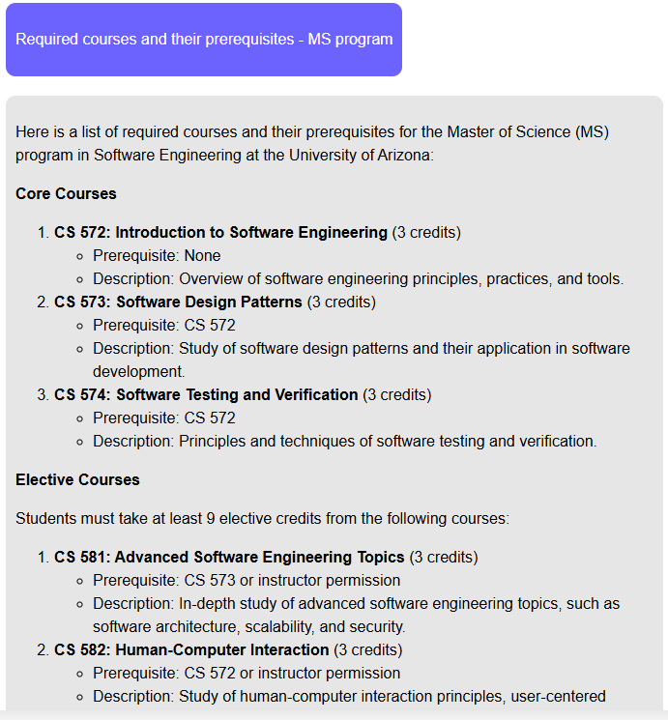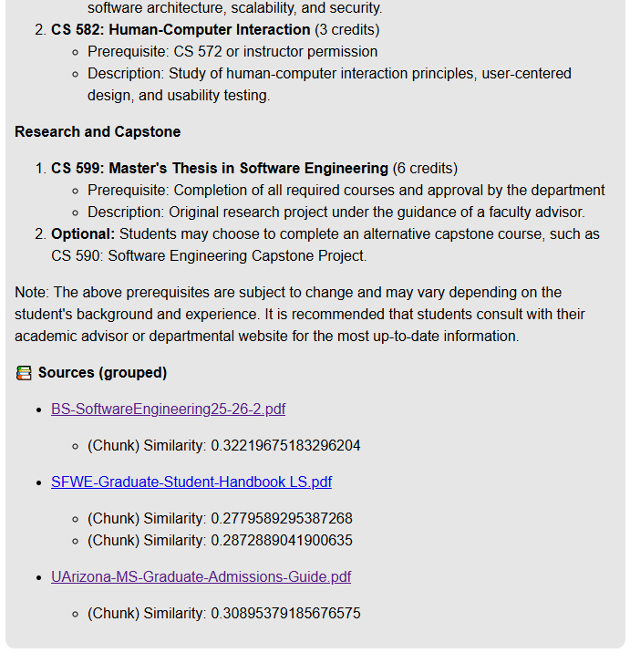

## Results: FAIL

Courses provide in query are not core courses for the MS in SFWE. It offered all CS classes not SFWE classes.

# Test Case 12: Possible Technical Electives – MS Program

## Steps:

1. Select **Possible Technical Electives – MS Program** from the drop-down menu
2. Press **Enter**
3. Evaluate response to match expected information.

## Expected Response:



## Chatty Catty Response:

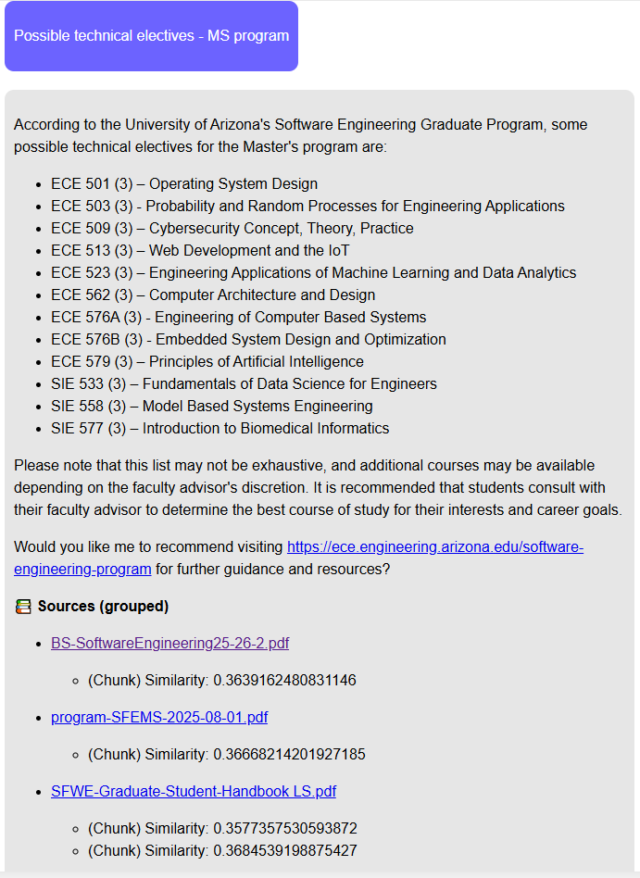

## Results: PASS

# Test Case 13: Information On Specialization Tracks – MS Program

## Steps:

1. Select **Information On Specialization Tracks – MS Program** from the drop-down menu
2. Press **Enter**
3. Evaluate response to match expected information.

## Expected Response:

Information found at <https://www.arizona.edu/degree-search/majors/software-engineering-ms>

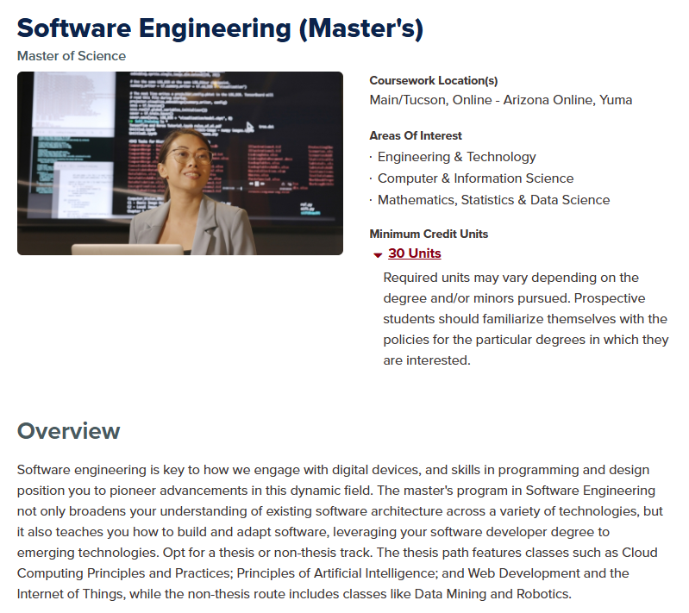

## Chatty Catty Response:

## Results: PASS

# Test Case 14: Thesis vs. Non-Thesis Options – MS Program

## Steps:

1. Select **Thesis vs. Non-Thesis Options – MS Program** from the drop-down menu
2. Press **Enter**
3. Evaluate response to match expected information.

## Expected Response:

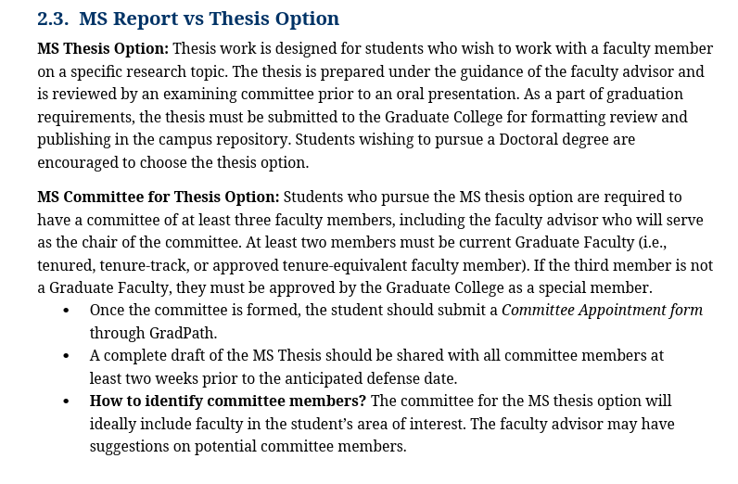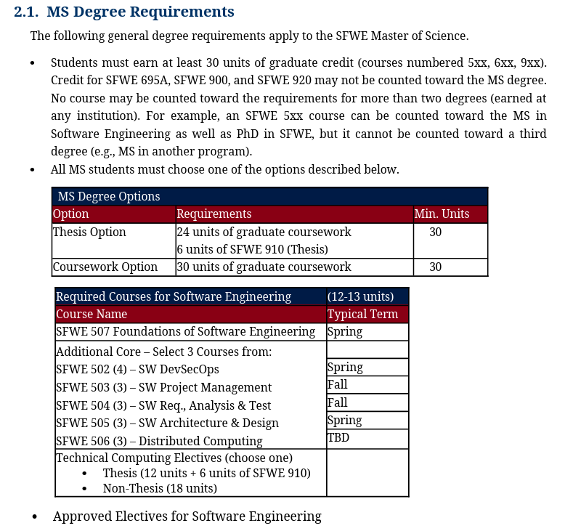

## Chatty Catty Response:

## Results: PASS

# Test Case 15: Graduate Admission Requirements – PhD Program

## Steps:

1. Select **Admission Requirements – PhD Program** from the drop-down menu
2. Press **Enter**
3. Evaluate response to match expected information.

## Expected Response:

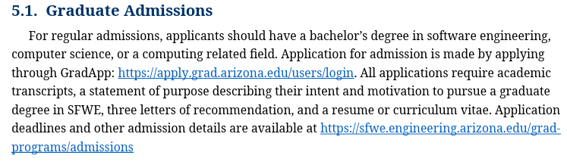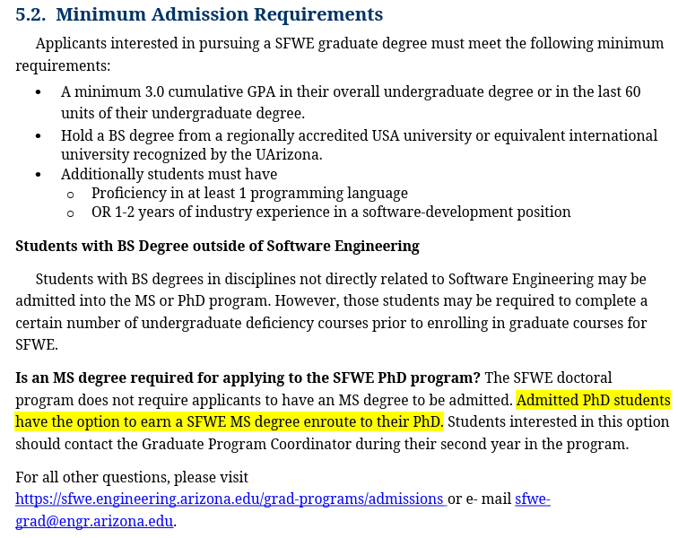

## Chatty Catty Response:

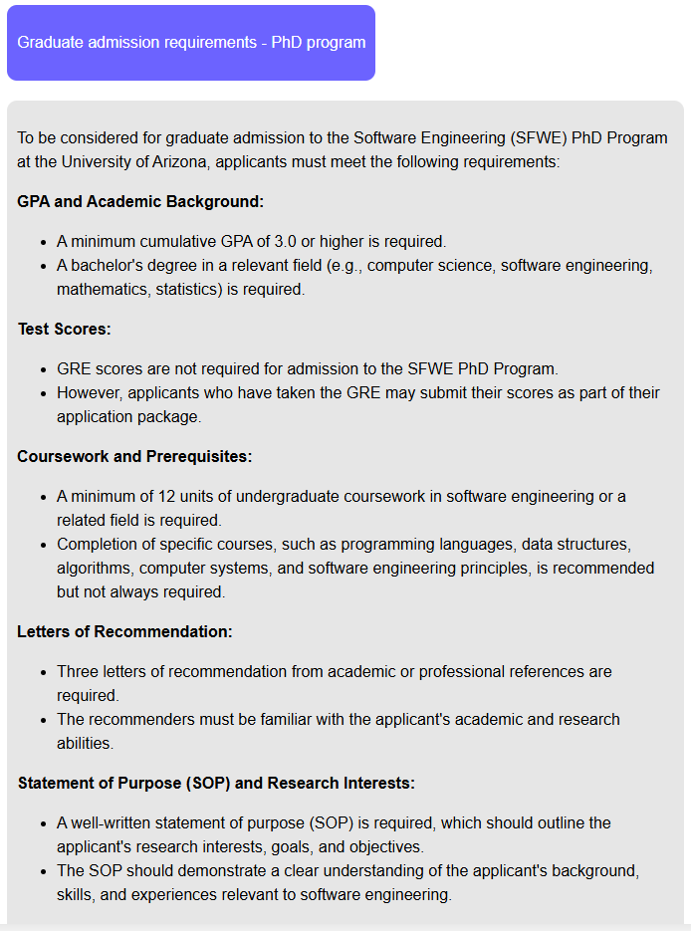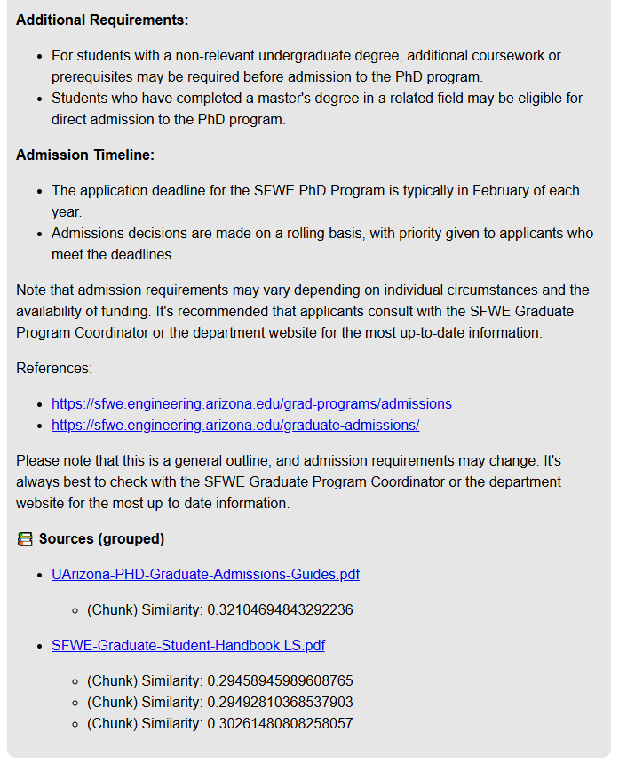

## Results: PASS

# Test Case 16: Required Course Work – PhD Program

## Steps:

1. Select **Required Course Work – PhD Program** from the drop-down menu
2. Press **Enter**
3. Evaluate response to match expected information.

## Expected Response:

## Chatty Catty Response:

## Results: PASS

# Test Case 17: Potential Minor Options – PhD Program

## Steps:

1. Select **Potential Minor Options – PhD Program** from the drop-down menu
2. Press **Enter**
3. Evaluate response to match expected information.

## Expected Response:

## Chatty Catty Response:

## Results: PASS

# Test Case 18: Required Course Prerequisites – PhD Program

## Steps:

1. Select **Required Course Prerequisites – PhD** from the drop-down menu
2. Press **Enter**
3. Evaluate response to match expected information.

## Expected Response:

## Chatty Catty Response:

## Results: PASS

# Test Case 19: Possible Technical Electives – PhD Program

## Steps:

1. Select **Possible Technical Electives – PhD Program** from the drop-down menu
2. Press **Enter**
3. Evaluate response to match expected information.

## Expected Response:

## Chatty Catty Response:

## Results: PASS

# Test Case 20: Guidance on Research Focus Areas and Faculty Advisors – PhD Program

## Steps:

1. Select **Guidance on Research Focus Areas and Faculty Advisors – PhD Program** from the drop-down menu
2. Press **Enter**
3. Evaluate response to match expected information.

## Expected Response:

## Chatty Catty Response:

## Results: PASS

# Test Case 21: Qualifying Exam Requirements – PhD Program

## Steps:

1. Select **Qualifying Exam Requirements – PhD Program** from the drop-down menu
2. Press **Enter**
3. Evaluate response to match expected information.

## Expected Response:

## Chatty Catty Response:

## Results: PASS

# Test Case 22: Dissertation Requirements – PhD Program

## Steps:

1. Select **Dissertation Requirements – PhD Program** from the drop-down menu
2. Press **Enter**
3. Evaluate response to match expected information.

## Expected Response:

## Chatty Catty Response:

## Results: PASS

# Test Case 23: Funding Opportunities – PhD Program

## Steps:

1. Select **Funding Opportunities – PhD Program** from the drop-down menu
2. Press **Enter**
3. Evaluate response to match expected information.

## Expected Response:

## Chatty Catty Response:

## Results: PASS